Forward Christmas Thinking

save trees save £££££ donate to the Abingdon RDA

Surprise your loved ones with a video greeting this Christmas. Personalise a festive scribe to create a visual treat that no one will forget.
It’s easy, costs just what you would like to donate, and makes a big impression.

You could share one on Facebook to greet all your friends at once. Or send the link to your relatives who live overseas.

Save a tree. Save time. Save a little money. Support Charity. Send a scribe.

Choose from the three designs below. Click to watch.

Add your own message, and even a photograph.
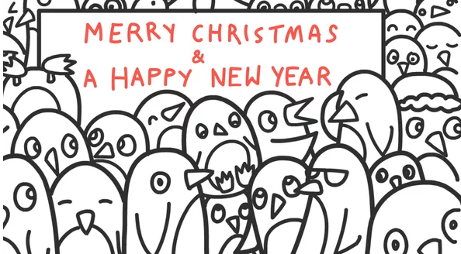
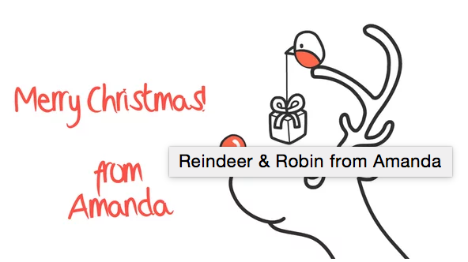
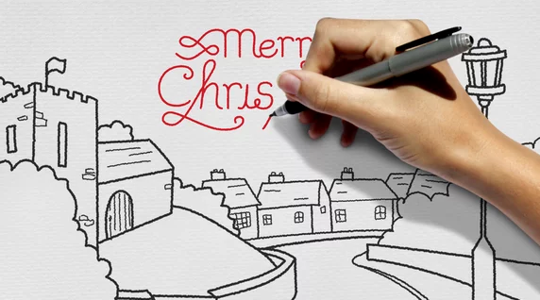

Contact me for further information or just send on your message and photos with your chosen design, make a donation (£5 minimum), and I will create your scribe and send you back your own personal link to it, we can agree one set of edits if needed and you’re good to go!

mailto:amanda@amandacreates.co.uk

